SoftwareRequirements Specification
for
<Hostel Management System>
Version 1.0
Prepared by <Kainat Nawaz> <Farah Qandeel Yousaf> <Aqib Ali>
<17-1-2019>
Table of Contents
Table of Contents 1
1. Introduction 2
1.1 Purpose 2
1.2 Document Conventions 2
1.3 Product Scope 2
2. Overall Description 2
2.1 Product Perspective 2
2.2 Product Functions 2
2.3 User Classes and Characteristics 3
2.4 Operating Environment 3
2.7 Assumptions and Dependencies 3
3. External Interface Requirements 3
3.1 User Interfaces 3
3.2 Hardware Interfaces 3
3.3 Software Interfaces 4
3.4 Communications Interfaces 4
4. System Features 4
4.1 System Feature 1 5
4.2 System Feature 2 5
4.3 system feature 3 6
4.4 system feature 4………………………………………………………………………………7
4.5 system feature 5………………………………………………………………………………8
5. Other Nonfunctional Requirements 9
5.1 Performance Requirements 8
5.2 Safety Requirements 8
5.3 Security Requirements 8
5.4 Software Quality Attributes 9
5.5 Business Rules 10

Introduction
Hostel Management System is a customized and user-friendly software for hostel which provides hostel information, hostel room information and hostel account information.
It helps admin to manage
- Student record
- Staff record
- Generating staff and student record

Purpose
Aim of the hostel management system is to create the program that keep the user’s record.

Document Conventions
Font size:
Main heading 18
Sub heading 14
Details 12
Font style: Times New Roman

Product Scope
For the past few years the number of educational systems is increasing rapidly. Thereby number of hostels are also increasing for the accommodation of the students studying in this institution. This project deals with the problems on managing a hostel and avoid the problems which occurs when carried manually.

Overall Description

Product Perspective
Our system has to store the data of students living in hostel and make it easier to add, maintain and delete the record of student.

Product Functions
The admin can add and delete the user
The user can register the student
User can delete the student
User can search the student
User can display the student
User can add the employee
User can delete the employee
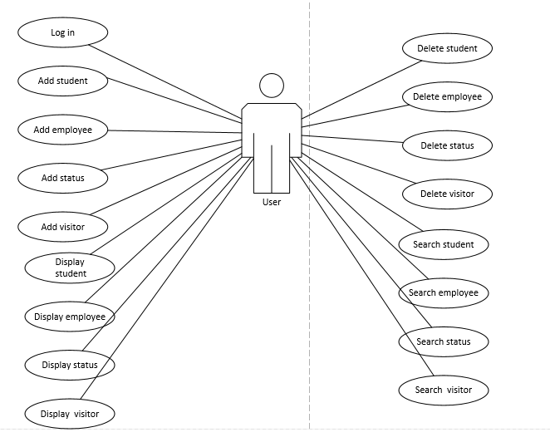
User can search the employee
User can Display the employee
User can Display the Visitor
User can Add the Visitor
User can Search the Visitor
User can Delete the Visitor
User can Add the Fees
User can delete the Fees
User can search the Fees
User can display the Fees

User Classes and Characteristic

Educational level: At least user of the system should be comfortable with English language.
Technical Expertise: User should be comfortable using general purpose applications in the system.

Operating Environment
Windows XP 7, 8, 10, VISITA

Design and Implementation Constraints
A hostel management system (HOMASY) was designed to provide a computerized process that is stress free, reliable and quick through the use of c# computer programming language and Oracle database application to both the students and the staff in charge of the registration and hostel management processes. C sharp would be at the front-end and provide the graphical user interface that relates with the user, while the Oracle database will be at the back-end to handle the data storage process. The porter and students' affairs officers will also be able to access and create student records with ease and regular update of student profile is enhanced when adopted. The existing procedure was formed to be manually carried out. This is associated with inadequacies as more personnel are often required and a lot of times are wasted while the semester is on with lectures and other activities.

Assumptions and Dependencies
- Extensive documentation is available with the client.
- User will be having a valid username and password to access the software.
- Complete training is provided to all end users to handle the products.
- The software would not take into account the business impact i.e. The risks associated with constraints imposed by the management or the market place.

External Interface Requirements

User Interface
- At the start, there will be a login screen where the user have to enter its login name and password to authenticate himself.
- After the login, a homepage will be displayed showing all the information and operations provided by the hostel management system.
- All the operations available at the homepage will have a specific routine that will be followed up in order to complete the operation.for each operation, a different screen will be displayed demanding and providing the information regarding the operation.
- A report will be generated for each student containing fee information, fines dues and penalties, check in and check out information.

Hardware Interfaces
- Screen resolution. 800x600 or higher.
- Support for printer that is, appropriate devices are installed and connected printer will be required for printing of the reports.
- Desktop system, handheld system not a concern, as it will be possible to run the application on any of these.

Software Interfaces
- Operating system: windows XP 7, 8, 10.
- Oracle as dbms for database.
- C# for coding, developing the software.

Communications Interfaces
Null

System Features

Login
Login information maintenance
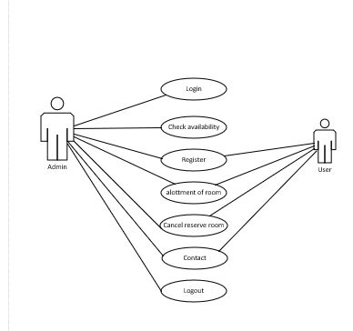
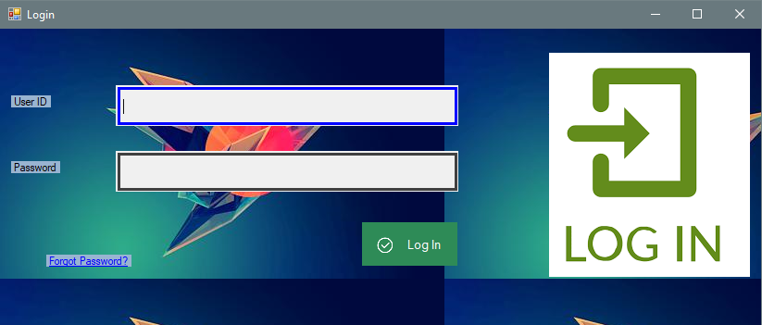
4.1.1 Description and Priority
The system will maintain the log in information of its users.
4.1.2 Stimulus/Response Sequences
Login information has to be filled in before the user is allowed to choose from the option such as menu item details, facilities and room details and payment details.
4.1.3 Functional Requirements
It should get user id and password and check whether it is valid or not.

4.2 Add Student
4.2.1 Description

The system will maintain the student information regarding the personal details of the student .it contains the name, address and phone no.of each resident that can be added/modified/deleted.
4.2.2 Response sequences
Resident information has to be filled in before the user is allowed choose from the options such as Menu Item details Facilities , Room details and payment details. If any of the sequencing flow does not hold true system will display proper error messages for the user to do the needful.
4.2.3 Functional Requirement
Student should be admitted in some department of corresponding institute.
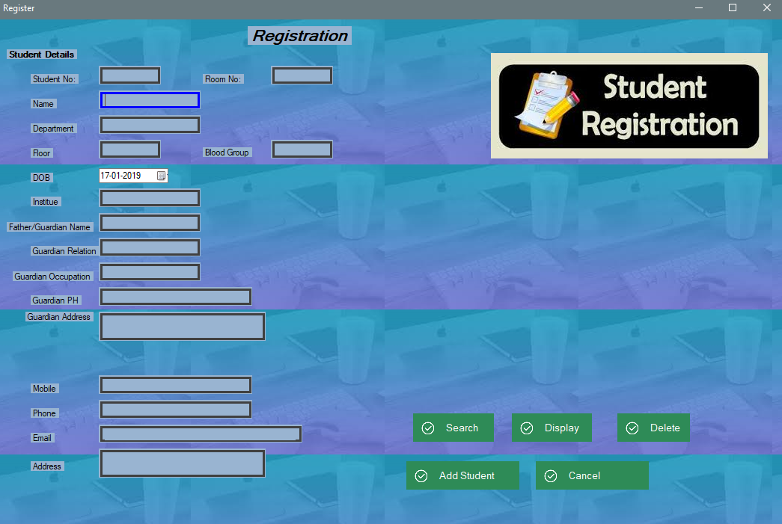

Add Employee

Description
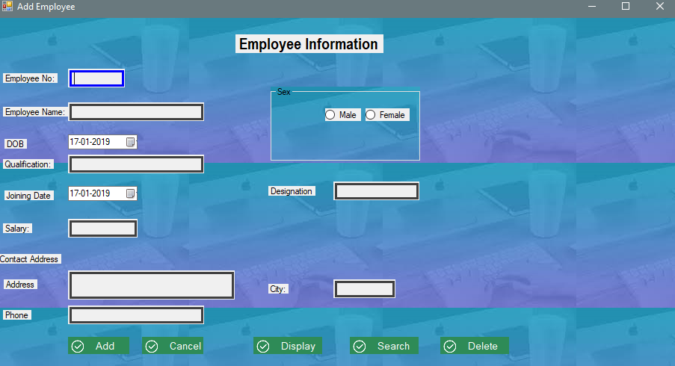
The system will maintain the employee information including an employee’s personal and professional details being needed by the organization. It contains the employee name, id no, address, phone no, department, designation, basic salary of each that can be added/modified/deleted.

Response sequences
Employee information has to be filled in every month for proper increments to be added to the employee salary.

Functional Requirement
If any of the sequencing flow does not hold true system will display poor error messages for the user to do the needful.

Add Status

Description
System will save the status of the student whether he/she is in hostel or not. What type of leave student has got.

Response sequences
Status has to be saved first. Then status of student can be displayed to user.

Functional Requirement
Student has to be added first in database. Then its status can be added.
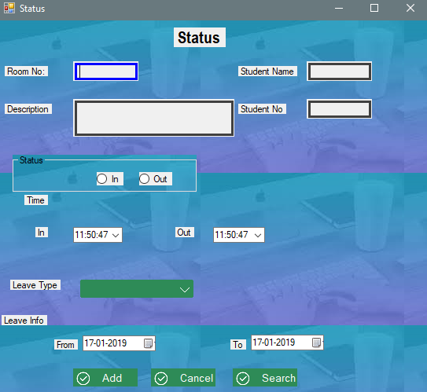

Add Visitor

Description
System will store the data of every visitor. Like Visitor name, Student that has a visitor and Room number of student.

Response sequences
Visitor can be added first and then its record can be deleted, search and displayed.

Functional Requirement
Student has to be added first in database. Then its Visitor can be added.

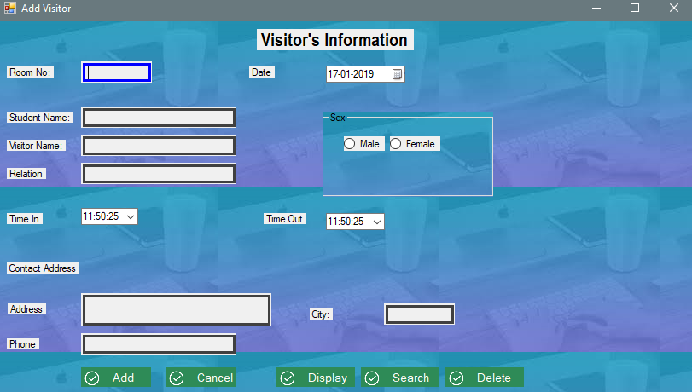5. Other Nonfunctional Requirements

Performance Requirements
Processor Pentium 4
RAM 1GB
Hard derive 100 GB

Safety requirements
The database may get crashed at any certain time due to virus or operating system failure. Therefore, it is required to take the database backup.

Security Requirements
Keep specific log or history data set,
1-Assign certain functions to different modules.
2- Restrict communication between some areas of the program.
3-Check data integrity for critical variables.
4-later version of the software will incorporate encryption techniques in the user /license authentication process.

Software Quality Attributes
- Security :
The system should be secure from the unauthorized access and should be password protected so that no other user can access it.
- Portability:
The system should be machine independent.
- Maintainability:
The system will be designed in a maintainable order. The system can be easily modified and renewed according to the need of the organization.

Business Rules
Obviously many students will be living in the hostel.
The hostel has many rooms for the accommodation of the students in which more than one student accommodate their self.
Each room has assigned different types of furniture for the students so they can easily spend the time in room.
There are many workers in the hostel who work in the mess and hostel as well(cleaning , washing etc.);
Every student must submit his fees in-time so they can get the every facility in hostel.
For the food service the hostel management is providing the facility of mess for students so students can easily get the meal in hostel.
It is also possible that visitors can come to meet students those are living in hostel.

